**🔗**[Matches Dataset](https://drive.google.com/file/d/10WEERPD3JoYoLrbhHzekTp_yi_pIb8kI/view?usp=drive_link)

**SQL QUERIES**

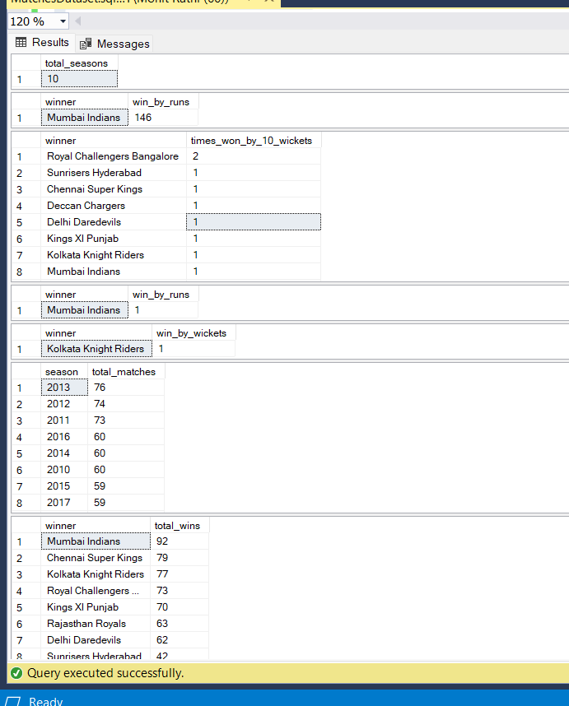

CREATE DATABASE MacthesDataset;

use MacthesDataset;

SELECT DISTINCT season FROM dbo.matches;

SELECT TOP 1 winner, win_by_runs FROM dbo.matches ORDER BY win_by_runs DESC;

-- 1. How many seasons we’ve got in the dataset?

SELECT COUNT(DISTINCT season) AS total_seasons FROM matches;

--2. Which Team had won by maximum runs?

SELECT TOP 1 winner, win_by_runs FROM matches ORDER BY win_by_runs DESC;

--3. Which Team had won by maximum wickets?

SELECT winner, COUNT(*) AS times_won_by_10_wickets

FROM matches

WHERE win_by_wickets = 10

GROUP BY winner

ORDER BY times_won_by_10_wickets DESC;

--4. Which Team had won by closest margin (minimum non-zero runs)?

SELECT TOP 1 winner, win_by_runs

FROM matches

WHERE win_by_runs > 0

ORDER BY win_by_runs ASC;

--5. Which Team had won by minimum wickets (non-zero)?

SELECT TOP 1 winner, win_by_wickets

FROM matches

WHERE win_by_wickets > 0

ORDER BY win_by_wickets ASC;

--6. Which Season had most number of matches?

SELECT season, COUNT(*) AS total_matches

FROM matches

GROUP BY season

ORDER BY total_matches DESC;

--7. Which IPL Team is more successful (most wins)?

SELECT winner, COUNT(*) AS total_wins

FROM matches

GROUP BY winner

ORDER BY total_wins DESC;

OUTPUT